Deborah Nemens

SEFS 535: Fire Ecology

December 14, 2016

Montane chaparral regeneration dynamics after repeated wildfires

**Introduction**

The ecological problems stemming from more than a century of fire exclusion in the forests of the western United States are well documented (Agee 1993, Taylor 2000, Hessburg et al. 2005). Frequently cited are the accumulation of unnatural fuel loads, increased landscape homogeneity, increased stand structural complexity, change in species composition, and biodiversity loss. These changes have caused a dramatic shift in fire regimes in many western forests, introducing high-severity fire to plant communities that may not have experienced it in hundreds or even thousands of years. The consequences of this regime shift for fire-excluded forests are often drastic when fire does return to the system. Under the novel regime of high-severity fire, fire behavior increases, and fire effects are often severe, producing large areas of complete overstory mortality in many formerly forested areas. Additionally, fire suppression has removed the primary agent of vegetative heterogeneity from the landscape, resulting in increased fuel connectivity and millions of acres of densely packed, homogenous forests (Bekker and Taylor 2010, Collins et al. 2016). This increased homogeneity compounds the effects of wildfires, allowing fire to spread more easily though connected fuels, increasing fire size and expanding the impacts of high-severity fire to a larger scale. (Frost 2007, Guiomar et al. 2015).

The dry mountainous regions of northeastern California have been heavily impacted by this phenomenon, and much of the landscape is experiencing fire return intervals and burn severities well outside of the historical range of variability. In the pre-European era, the Sierra mixed conifer forests typical of the region experienced a low to moderate severity fire regime, with average fire return intervals between 4 and 20 years reported (Bekker & Taylor 2010; Taylor 2000, 2010a). Many areas were affected by regular burning by Native Americans for a variety of resource objectives (Stewart et al. 2002, Anderson 2005). Indigenous burning may have significantly increased fire frequency beyond what might be expected if climate was the primary driver of fire regimes (Taylor et al. 2016). As in many dry forests of the west, cessation of anthropogenic burning in conjunction with subsequent suppression policies have led to dramatic increases in fire return intervals and forest densities, with resultant increases in fire severity (Agee 1993, Skinner and Taylor 2006, Taylor 2010). In mixed-conifer forests that are adapted to frequent low and moderate-severity fire, these human-moderated alterations have provoked dramatic outcomes in modern times.

In historic fire-mediated landscapes, irregular patterns of disturbance on the landscape created forest gaps and clearings where shrublands and grasslands could persist (Skinner and Taylor 2006, Knapp et al. 2012, Collins and Roller 2013). The shrub communities that intermixed with Sierra mixed conifer forests at mid elevations are composed of montane chaparral, a shrub-dominated ecosystem (referred to as chaparral for the remainder of this paper). Chaparral is not tolerant of low-light environments, and shrubs thrive in forest gaps. These gaps have filled in with trees in the decades since the removal of fire’s influence on the landscape, reducing the size and extent of shrubfields, and in many cases eliminating them altogether (Collins and Roller 2013, Knapp et al. 2012, Lauvaux et al. 2016). Recent mixed and high-severity fires may be returning historic heterogeneity to California’s landscape. It has been well documented that following a single fire event, montane chaparral often replaces mixed-conifer forest following high-severity burns (Collins and Roller 2013, Keeley, Nagel and Taylor 2005), and it has been posited that this constitutes a type shift from forest to shrub-dominated ecosystems (Lauvaux et al. 2016). Chaparral is characterized by high-severity crown fires that result in stand replacement (Keeley 2005, Sugihara et al). Several authors conclude that chaparral exists as a fire-mediated alternative vegetative state to mixed-conifer forests (Coppoletta et al. 2016, Lauvaux et al. 2016). Coppoletta et al (2016) found that vigorous shrub growth after severe fire increases the likelihood of reburn at high severity, given a minimum of 10 years regrowth between fires. The temporal persistence of this self-reinforcing vegetative community on the landscape is unknown. However, given the role of wildfire in mediating this trend and future predictions of larger, hotter fires in California, it can be predicted to be long-term.

As a vegetation type that is periodically subjected to high-severity fire, chaparral species have developed varied post-fire regeneration strategies. These adaptations include species that rely on below-ground carbohydrate reserves, often stored in lignotubers, which allow plants to sprout vigorously from basal bud banks after top-kill in fire (Keeley and Zedler 1978, Odion and Davis, Wells, 1969). Other species experience fire-stimulated germination of long-lived seeds stored in the seedbank (Keeley and Zedler 1978, Keely 1991, Wells 1969). These species can be categorized as “fire-endurers” and “fire-evaders”, respectively (Rowe 1983). For analysis of post-fire impacts, chaparral species are often grouped into these two rough categories. However, many species rely on differential regeneration strategies that are dependent on fire severity, eluding easy categorization (USDA Forest Service).

A number of studies have examined the effects of close-succession reburns on shrub and functional group dominance (Donato et al. 2009, Collins et al. 2009, Coppoletta et al. 2016), and some have studied individual species’ response to a single fire (Keeley et al. 2005; Keeley and Zedler 1978), but few have studied shifts in species composition resulting from short-interval repeated fire events. Since dominant chaparral species differ in their fire-response mechanisms, and some of these species exhibit multiple regeneration severity-dependent strategies, repeated fires may have divergent impacts on post-fire species assemblages, with implications for future community composition. In the context of climate change and the predicted increase in both frequency and severity of wildfires, short-interval reburns may become the norm in these quickly regenerating fuel types. This novel fire regime may favor species with particular regenerative capacities. I used data collected after two successive mixed-severity wildfires in the Lassen National Forest of northern California to assess post-reburn dynamics in these systems, and two ask the following questions: 1) does frequent fire favor one regeneration strategy over the other? And 2) how does burn severity combination impact the resulting dominance of individual chaparral species?

**Methods**

*Study site*

The study site was located within the intersection of the Storrie and Chips Fire footprints in the far southern extent of the Cascade Range in the Lassen National Forest of northern California (Figure 1). Soils of the site are typically young, and of volcanic origin, with granitic soils in the southernmost portion of the study area, where the Cascades intersect the Sierra Nevada Range (Cocking et al, 2014). Climatic patterns are Mediterranean, with warm dry summers, and cool, wet winters, during which 95% of the annual precipitation is received. Elevations range from 900 to 2300 meters above sea level, with steep slopes dominating the terrain. Common overstory species are ponderosa pine (*Pinus ponderosa*), sugar pine (*Pinus lambertina*), Douglas fir (*Pseudotsuga menzezii*), white fir (*Abies concolor*), and incense cedar (*Calocedrus decurrens*), and California black oak (*Quercus kelloggii*). Common shrub species in montane chaparral stands are obligate seeder deerbrush (*Ceanothus integerrimus*), facultative sprouter/seeders greenleaf manzanita (*Arctostaphylos patula*), snowbrush (*Ceanothus velutinus var. velutinus*), Sierra gooseberry (Ribes roezlii var. roezlii), and mountain whitethorn (*Ceanothus cordulatus*), and obligate sprouter trailing snowberry (*Symphoricarpos mollis*).

The Storrie Fire burned approximately 20,000 ha in August of 2000 in both the Plumas and Lassen National Forests (N.F.) The Chips Fire burned approximately 30,000 ha in the same area, beginning in the Feather River canyon of the Plumas N.F., and quickly moving onto the Lassen N.F. in August of 2012. The Chips Fire burned into the footprint of the Storrie Fire, creating a reburn area approximately 9,900 ha in size. Both fires burned with a mix of fire severities, allowing sampling across a spectrum of fire severities.

Figure 1: Map of study area in Lassen and Plumas National Forests. Storrie Fire (2000) footprint is outlined in blue, Chips Fire (2012) footprint is outlined in black.

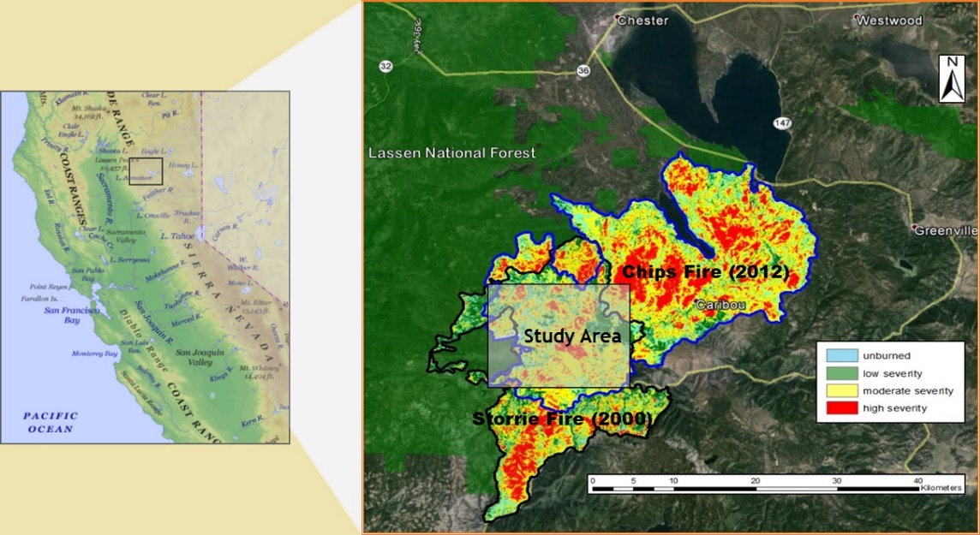

*Field sampling*

Data collection occurred in the summer of 2015, three years after the Chips Fire, and 15 years after the Storrie Fire. Ninety-three randomly established fixed-area plots were sampled inside and adjacent to the reburn area. Plots were evenly distributed across the spectrum of burn severities for both fires, and ranged in elevation from 900 to 1400 meters. Shrub sampling plots were established by locating the closest living California black oak (*Quercus kelliggii*) above 137 cm in height, and using that individual as the locus for a 10-meter radius circular sub-plot. Within each 314m² circular plot, ocular estimates of percent cover for all shrub species were recorded in two equally sized quadrants using the following cover classes: 1: <1%, 2: 1-10%, 3: 11-25%, 4: 26-50%, 5: 51-75% and 6: >76%. Overstory mortality was recorded for all trees with diameters greater than 2.5cm, and Storrie or Chips Fire-caused mortality designations were made based on snag condition class (Thomas et al, 1979) and other visual cues (e.g., substantial consumption of dead stems in second fire).

*Data analysis*

Burn severity was determined using field measurements of overstory canopy removal in the Storrie and Chips Fires, and classified into two categories: low severity (less than 75% overstory removal) and high severity (75% and greater overstory removal). The 75% overstory mortality limit was used because many of the recorded species demonstrate severity-dependent regeneration strategies, with changes in mechanism of response occurring at the high severity threshold. Each category was then combined for both burns in order to examine interactive fire effects, producing four combined categories of Storrie Fire followed by Chips Fire burn severity: low/low, low/high, high/low and high/high. These categories were used as predictor variables for the analysis of post-fire species composition.

Table 1: Frequency (proportion of plots where species occurred) and mean percent cover of the six most commonly documented species.



The six most frequently occurring mid-story shrub species were selected for analysis (Table 1). Cover class midpoints from each quadrant were doubled to calculate plot percent cover estimates for each of these species. Because these observations were made after variable regrowth periods following each fire (15 and 12 years, respectively), relative percent cover was calculated in order to be able to compare canopy dominance across fire severity combinations. Dominant species were classified as obligate sprouters, obligate seeders, or facultative sprouters or seeders, according to post-fire regeneration strategy as documented in the Fire Effects Information System (USDA Forest Service).

**Results**

Relative cover of seeding species was far higher than sprouting species across all fire severity combinations (Figure 2, Table 2). ANOVA tests for all species were significant at the .05 level. Deerbrush, an obligate seeder, had the greatest relative abundance at all severity combinations. Mountain whitethorn, showed a marked increase in relative cover in sites that burned twice at high severity, indicating that it responds positively to multiple high severity burns. This species shows a varied fire response, sprouting at lower severities and relying on fire-stimulated germination at higher severities. My results indicate that whitethorn may be more successful when employing a strategy of fire-stimulated germination from the seedbank. Both greenleaf manzanita and snowbrush represented a higher proportional abundance after a single high severity fire, but relative cover decreased after reburn at high severity, indicating that multiple burns may reduce its vigor, and subsequent ability to resprout. Sierra gooseberry did not demonstrate any strong trends. This species is also classified as a facultative seeder, although little information is available on its response mechanism at different burn severities (Ulev 2006). Obligate sprouter trailing snowberry seemed to decrease under any combination that included a high-severity fire, which may be a result of competition with other species, as it is catalogued as a weak sprouter after fire (Snyder 1991).

Table 2: Means for ANOVA tests on each chaparral species examined for this study. Shaded cells indicate significant departure from the overall mean for each test at .05 significance level.



**Discussion**

Figure 2: Response of common species (measured by relative percent cover) to each burn severity combination. Species appear in a gradient from obligate seeder (deerbrush) in the upper left, to obligate sprouter in the lower left (snowberry). Blue lines represent overall means for each species. (* indicates significant departure from overall mean)

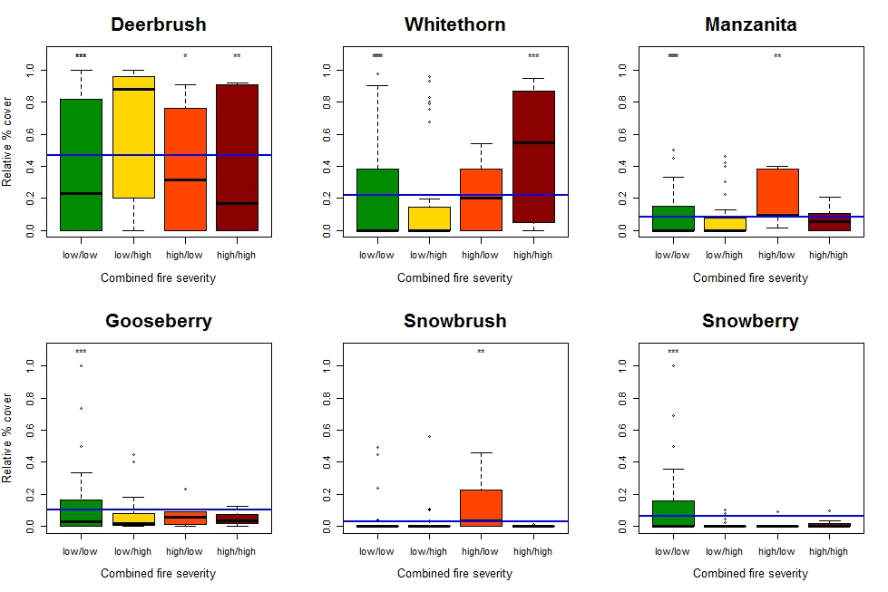

The compounding effects of large-scale high-severity fire events have the capacity to transform landscapes over long time periods. Predicting the future vegetative trajectories of these stand-replacing events in maladapted systems is important for understanding the long-term consequences of more than a century of fire exclusion in western forests. Conclusions drawn from the study of current vegetation dynamics can help create land management policies that are sustainable in the long term.

Chaparral may persist in formerly forested areas through a self-reinforcing cycle of high-severity reburn (Nagel and Taylor 2005, Coppoletta et al. 2016), although our study’s stratified sampling design does not allow investigation of this hypothesis. The role of fire in influencing biota is well known, and researchers are increasingly finding that frequent fire can sustain these transposed ecosystems. Frequent fire kills trees as well as their seed banks, making forest regeneration difficult (Nagel and Taylor 2005). Pines, the dominant conifer genera in this region, exhibit poor regeneration following high-severity fire likely due to their lack of shade-tolerance and lower soil moistures occurring in the presence of a quickly regenerating shrub canopy (Nagel and Taylor 2005, Collins and Roller 2013). Pine recruitment can be especially slow if high-severity burn patches are large, and seed sources are distant as a consequence (Lauvaux et al, 2016). Post-fire chaparral colonization, coupled with limited tree recruitment, may lead to an inescapable cycle of frequent high-severity fire in these ecosystems, preventing the recruitment of trees and the conversion of these areas back to forest. These type-shifts may be of limited duration, but there is considerable evidence that the impact of stand-replacing fires in this region can last decades or even centuries (Lauvaux et al. 2016; Nagel and Taylor 2005).

Several researchers have found that post-burn dynamics in chaparral systems are significantly dependent on the length of the interval between fires. Our study looked at a 12-year interval between fires, and observed similar trends to the findings of Donato et al (2009), who examined a 15-year interval, and concluded that seeding species maintained dominance in short-interval reburns. However, sufficient fire-free intervals are necessary for the both the restoration of below-ground carbohydrate reserves as well as replenishment of seed banks. Keeley et al. (2005) found that a four-year interval was not sufficient for seeding species to redevelop a depleted seedbank, which might indicate that shorter intervals (of less than a decade) may favor sprouters. Thus, varied intervals may produce different outcomes. Additionally, reburns typically consume large quantities of downed woody debris in smoldering fires, producing variability in soil heating that can have a strong influence on the port-fire survival of seed banks as well as lignotubers and other structures necessary for resprouting (Donato et al. 2009, Knapp et al. 2012). Consequently, our results may only be applicable to similar reburn conditions with comparable fire-free intervals.

While the conversion of mixed-conifer forests to chaparral-dominated shrublands is likely to increase fire behavior in these systems, it is not clear what the implications of shifts in species assemblage are for future fire behavior. Cycles of short-interval reburn may become more common in California, particularly in the likely scenario of a warmer and drier climate. Recent research has attributed much of the recent increase in duration of the fire season as well as wildfire size and severity to climate change, and this trend is expected to continue as temperatures rise globally (Abatzoglou and Williams 2016). As such, feedback loops perpetuated by high-severity fire could become the “new normal” in California’s wildlands.

Our results, as well as those of other studies, indicate that fire regimes with a return interval of approximately a decade cause species compositional changes in chaparral systems. Since flammability between individual chaparral species may vary considerably, our findings may have additional implications for fire behavior in frequently burned sites. Studies examining differential flammability of montane chaparral species are lacking, and present a potential avenue for future research with strong management implications. While a reduction in fire return intervals may produce negative outcomes from the perspective of local forest managers, they may produce positive results on a regional scale. These altered fire regimes have the ability to restore landscape heterogeneity, and may eventually become self-limiting, as increased patchiness also results in discontinuity of fuels. As cycles of high-severity reburn form on a local scale, we may be observing the return of truly mixed-severity fire regimes on a regional scale. This trend has the potential to reverse the legacy of decades of fire exclusion, leading to increased beta biodiversity and the restoration of critical disturbance pathways on the landscape.

**Literature Cited**

Abatzoglou, J. T., and A. P. Williams. 2016. Impact of anthropogenic climate change on wildfire across western US forests. Proceedings of the National Academy of Sciences of the United States of America 113:11770–11775.

Agee, J. K. 1993. Fire ecology of Pacific Northwest forests. Island Press, Washington, D.C. :

Anderson, K. 2005. Tending the wild : Native American knowledge and the management of California’s natural resources. University of California Press.

Bekker, M. F., and A. H. Taylor. 2010. Fire Disturbance, Forest Structure, and Stand Dynamics in Montane Forests of the Southern Cascades, Thousand Lakes Wilderness, California, USA. Ecoscience 17:59–72.

Collins, B. M., J. M. Lydersen, D. L. Fry, K. Wilkin, T. Moody, and S. L. Stephens. 2016. Variability in vegetation and surface fuels across mixed-conifer-dominated landscapes with over 40 years of natural fire. Forest Ecology and Management 381:74–83.

Collins, B. M., J. D. Miller, A. E. Thode, M. Kelly, J. W. van Wagtendonk, and S. L. Stephens. 2009. Interactions Among Wildland Fires in a Long-Established Sierra Nevada Natural Fire Area. Ecosystems 12:114–128.

Collins, B. M., and G. B. Roller. 2013. Early forest dynamics in stand-replacing fire patches in the northern Sierra Nevada, California, USA. Landscape Ecology 28:1801–1813.

Coppoletta, M., K. E. Merriam, and B. M. Collins. 2016. Post‐fire vegetation and fuel development influences fire severity patterns in reburns. Ecological Applications.

Donato, D. C., J. B. Fontaine, W. D. Robinson, J. B. Kauffman, and B. E. Law. 2009. Vegetation Response to a Short Interval between High-Severity Wildfires in a Mixed-Evergreen Forest. Journal of Ecology 97:142–154.

Frost, C. 2007. Fine-Scale Mapping of Presettlement Fire Regimes and Vegetation: A New Approach. Page 92nd International Joint Annual Meeting of the Ecological Society of America and Society for Ecological Restoration.

Guiomar, N., S. Godinho, P. M. Fernandes, R. Machado, N. Neves, and J. P. Fernandes. 2015. Wildfire patterns and landscape changes in Mediterranean oak woodlands. The Science of the total environment 536:338–52.

Hessburg, P. F., J. K. Agee, and J. F. Franklin. 2005. Dry forests and wildland fires of the inland Northwest USA: Contrasting the landscape ecology of the pre-settlement and modern eras. Pages 117–139Forest Ecology and Management.

Jon E . Keeley and Paul H . Zedler. 1978. Reproduction of Chaparral Shrubs After Fire : A Comparison of Sprouting and Seeding Strategies. The American Midland Naturalist 99:142–161.

Keeley, J. E., A. H. Pfaff, and H. D. Safford. 2005. Fire suppression impacts on postfire recovery of Sierra Nevada chaparral shrublands. International Journal of Wildland Fire 14:255.

Knapp, E. E., C. P. Weatherspoon, and C. N. Skinner. 2012. Shrub Seed bankS in mixed conifer foreStS of northern california and the role of fire in regulating abundance. Fire Ecology 8.

Lauvaux, C. A., S. and C. N., and A. H. Taylor. 2016. High severity fire and mixed conifer forest-chaparral dynamics in the southern Cascade Range, USA. Forest Ecology and Management 363:74–85.

Nagel, T. A., and A. H. Taylor. 2005. Fire and persistence of montane chaparral in mixed conifer forest landscapes in the northern Sierra Nevada, Lake Tahoe Basin, California, USA. The Journal of the Torrey Botanical Society 132:442–457.

Rowe, J. 1983. Concepts of fire effects on plant individuals and species. Pages 135–54*in* R.W. Wein and D. A. Maclean, editor.The role of fire in northern circumpolar ecosystems. John Wiley and Sons, New York.

Skinner, C. N., and A. H. Taylor. 2006. Southern Cascades Bioregion. Pages 195–224Fire in California’s Ecosystems. University of California Press.

Snyder, S. A. 1991. Symphoricarpos mollis. Page Fire Effects Information System, [Online]. U.S. Department of Agriculture, Forest Service, Rocky Mountain Research Station, Fire Sciences Laboratory (Producer).

Stewart, O. C., H. T. Lewis, and K. Anderson. 2002. Forgotten fires : Native Americans and the transient wilderness. University of Oklahoma Press.

Taylor, A. H. 2000. Fire regimes and forest changes in mid and upper montane forests of the southern Cascades, Lassen Volcanic National Park, California, U.S.A. Source Journal of Biogeography Journal of Biogeography 27.

Taylor, A. H. 2010. Fire disturbance and forest structure in an old-growth Pinus ponderosa forest, southern Cascades, USA. Journal of Vegetation Science 21:561–572.

Taylor, A. H., V. Trouet, C. N. Skinner, and S. Stephens. 2016. Socioecological transitions trigger fire regime shifts and modulate fire–climate interactions in the Sierra Nevada, USA, 1600–2015 CE. Proceedings of the National Academy of Sciences 113:13684–13689.

Thomas, J.W.; Anderson, R.G., Maser, C. and Bull, E. L. 1979. Wildlife Habitats in Managed Forests—The Blue Mountains of Oregon and Washington. Pages 60–77USDA Agricultural Handbook 553. USDA, Washington, DC.

Ulev, E. 2006. Ribes roezlii. U.S. Department of Agriculture, Forest Service, Rocky Mountain Research Station, Fire Sciences Laboratory (Producer). http://www.fs.fed.us/database/feis/plants/shrub/ribroe/all.html.

USDA Forest Service. (n.d.). Fire Effects Information System (FEIS) [online].